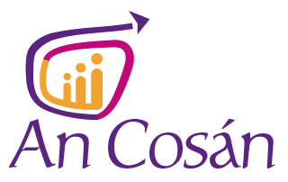

APPLICATION FORM
Communications and Information Officer
Name:_____________________________________
Please complete the following sections (maximum of 500 words per section)
Positively impacting online presence: Please summarise your experience in a relevant communications role, focussing in particular on where you have significantly impacted the online presence of an organisation, including tangible evidence of your positive impact.
Digital communication: Please outline your knowledge of digital communication tools and social media, and explain how you keep informed on emerging trends. Which emerging trends have you identified in recent times and to which you were an earlier adaptor.
Focus on storytelling and case studies: Please provide examples (with hyperlinks, if possible) which demonstrate your ability to use compelling storytelling and case studies as an effective part of your communication strategy.
Content and Information Management Systems: Please outline how you ensure that all published information is accurate and remains up to date – what systems and processes do you employ to ensure this? How do you navigate an organisation to ensure that you successfully engage with the appropriate stakeholders for accurate content management.
Community Education: Please outline your understanding, philosophy and experience of community education.
Is there anything that would affect your ability to carry out any of the requirements of this role?

What is your current salary/salary expectations?

REFEREES
Referee one
Name:
Job title:
Postal address:
Email address:
Telephone no:

Referee two
Name:
Job title:
Postal address:
Email address:
Telephone no:

Referee three
Name:
Job title:
Postal address:
Email address:
Telephone no:

This post is part funded by Pobal under the Community Services Programme

